

@SIGNUP FOR GITHUB

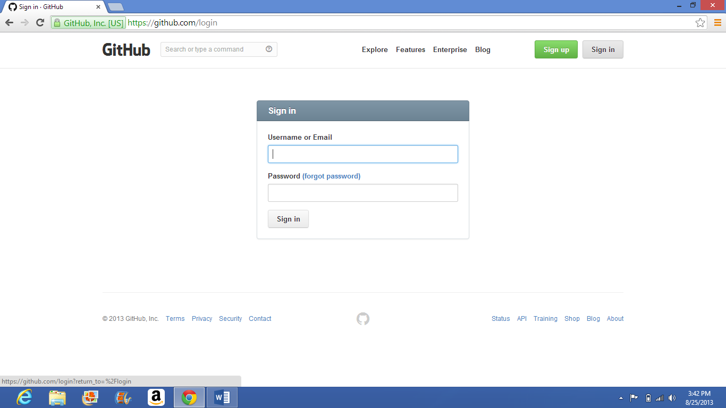

@LOGIN FOR GITHUB

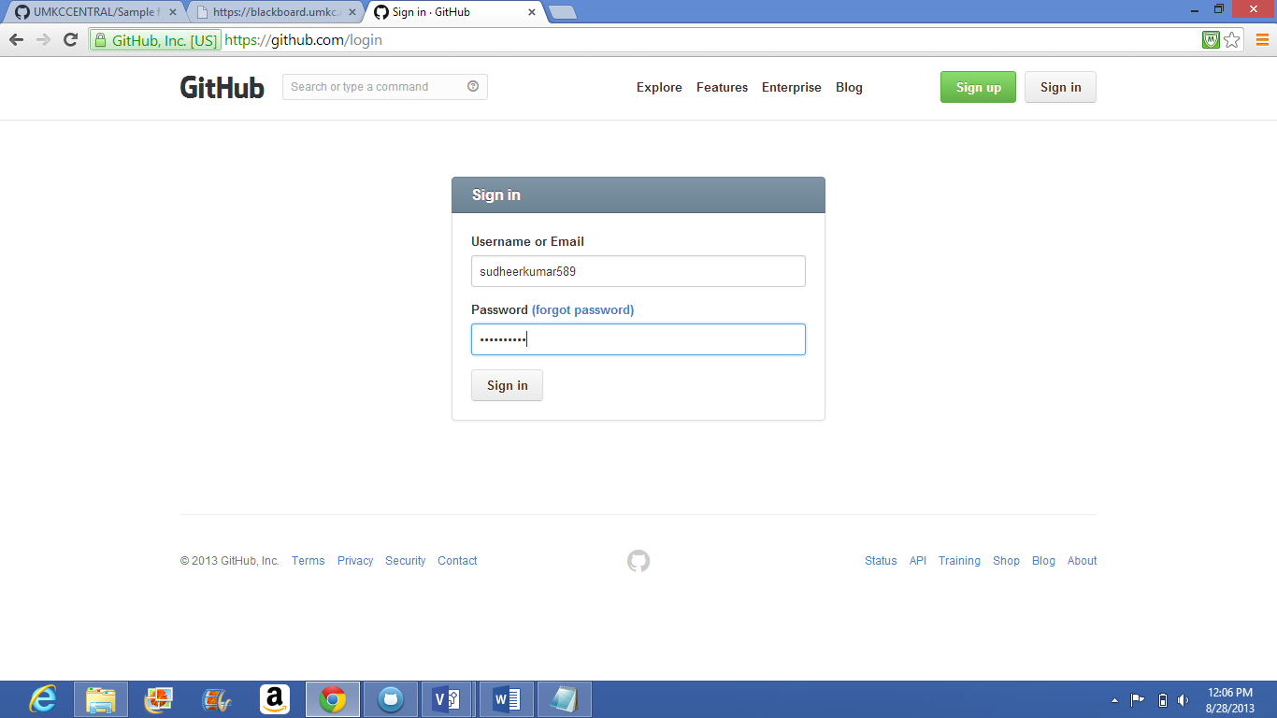

@ENTERING CREDENTIALS

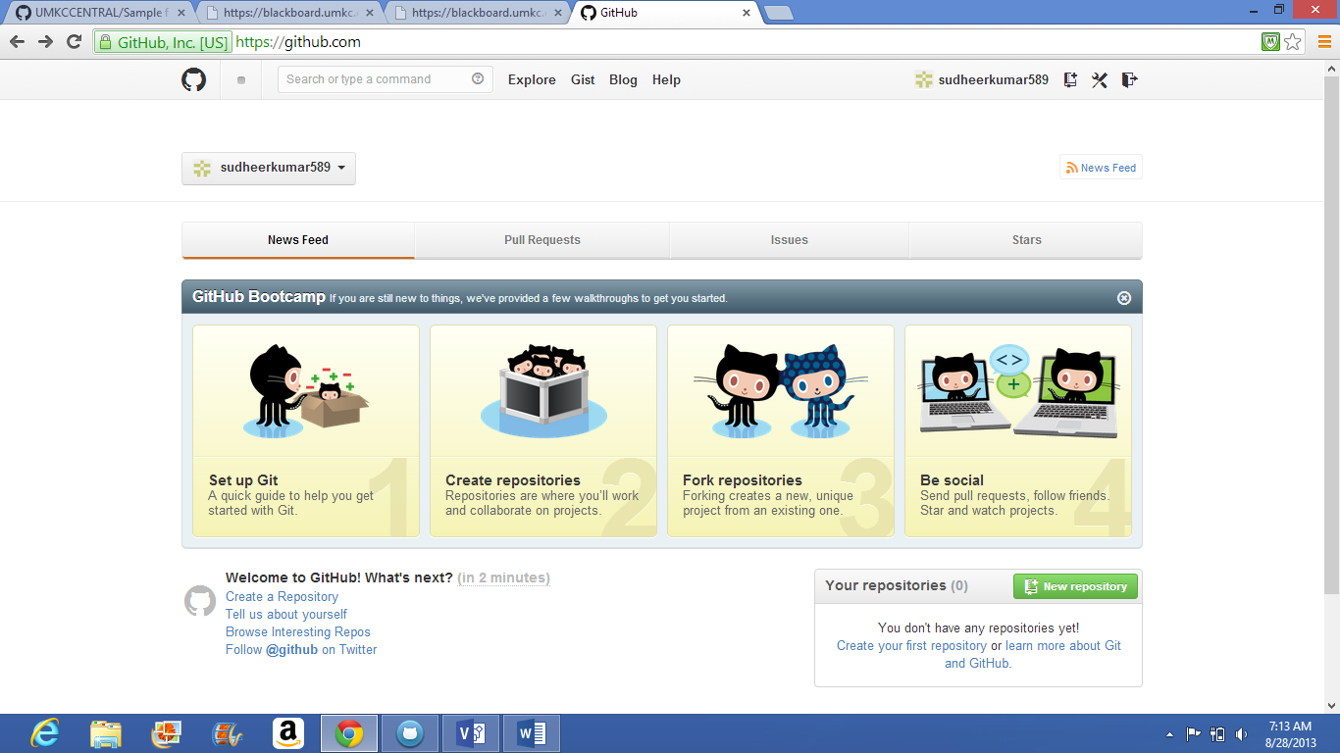

@HOME PAGE

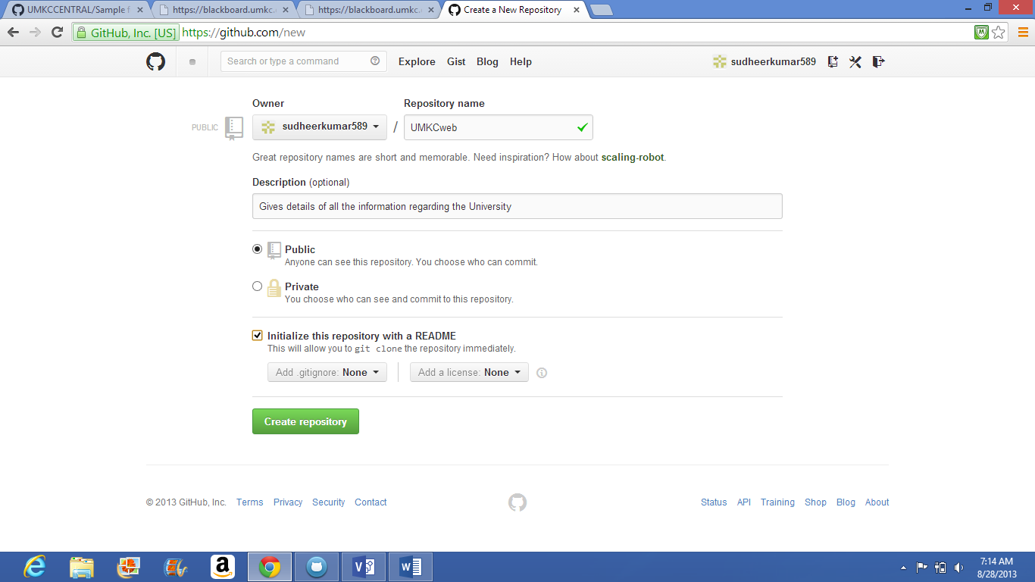

@ CREATING REPOSITORIES

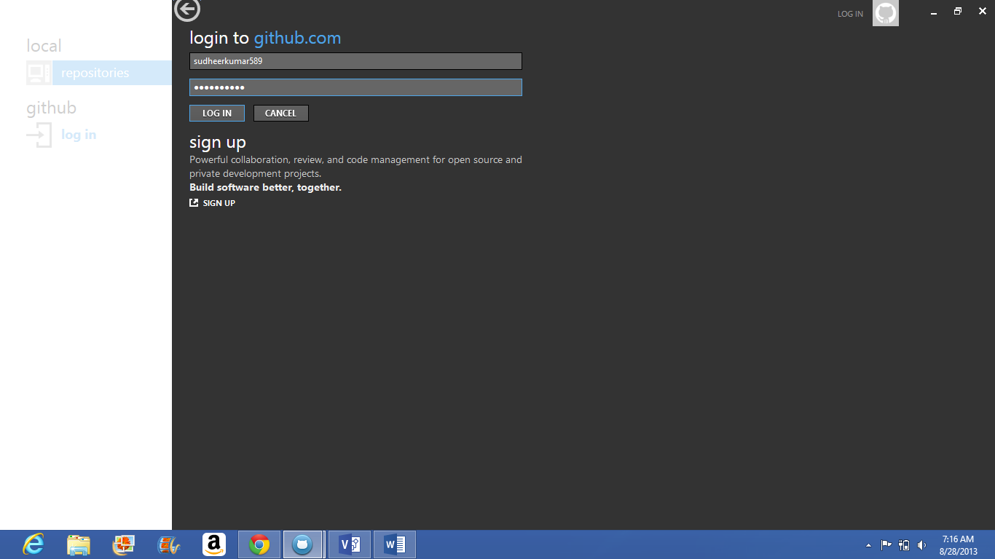

@SIGNUP FOR GITHUB IN DESKTOP

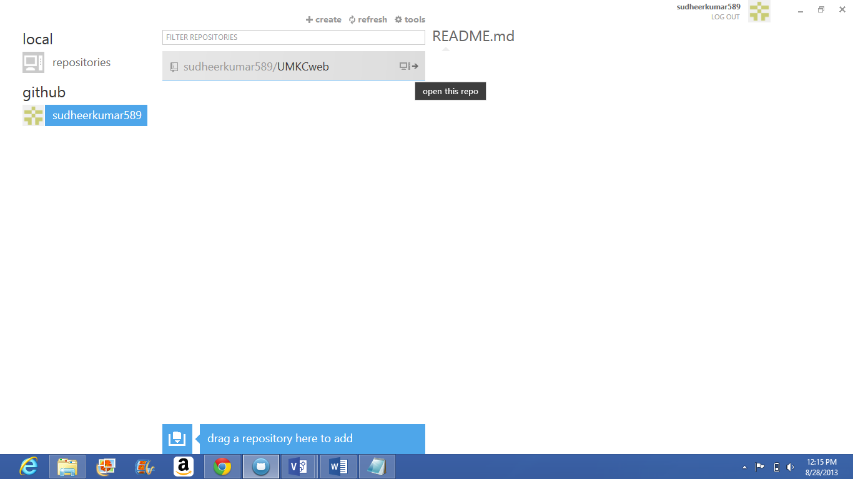

@HOME PAGE FO GITHUB IN DESKTOP

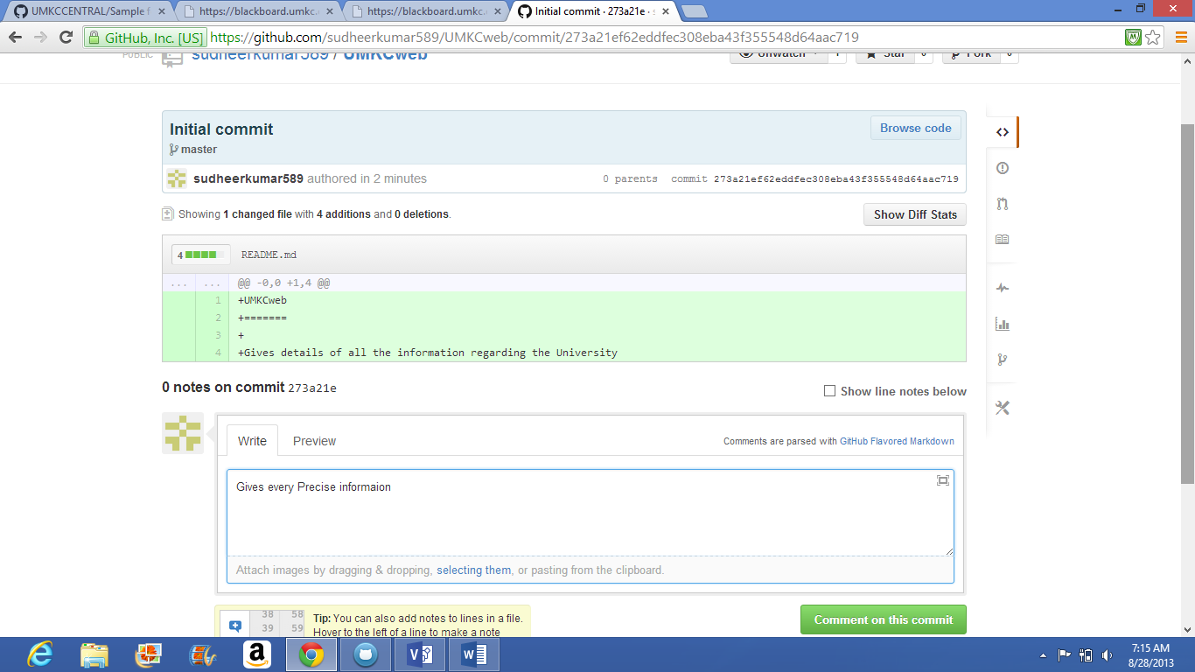

@INITIAL COMMITING

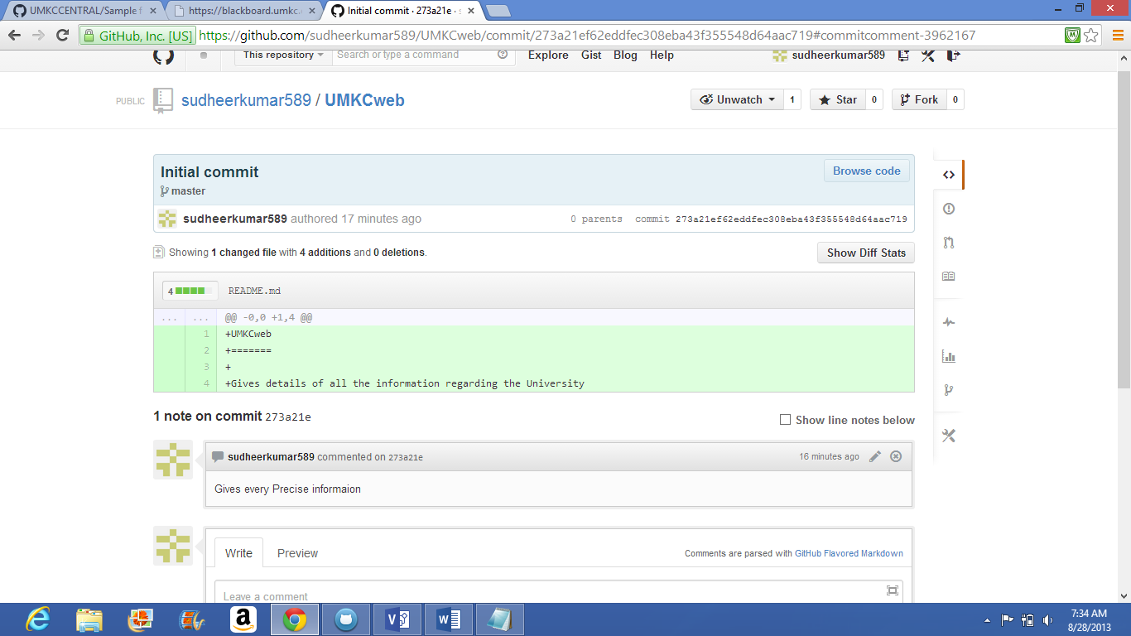

@MAKING A COMMENT



@CREATING A FILE

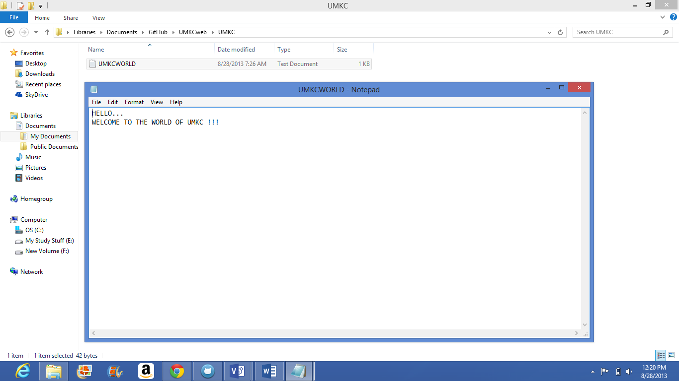

@CREATING A TEXT DOCUMENT

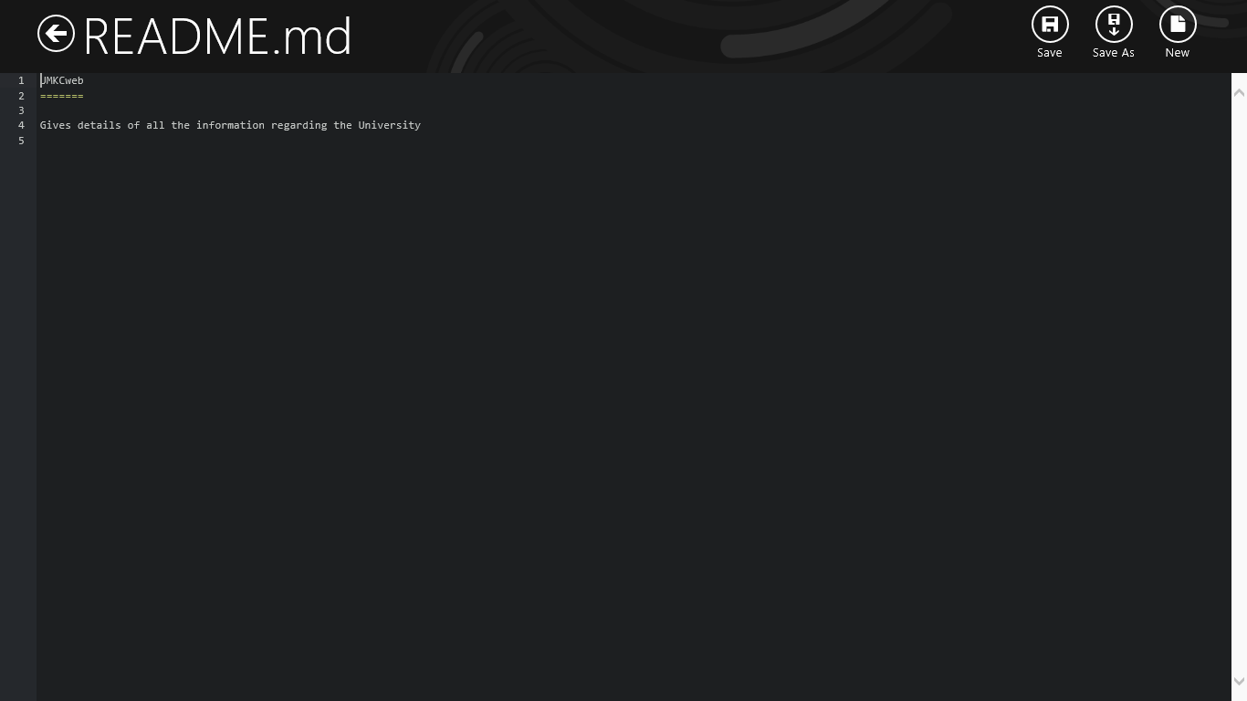

@README FILE

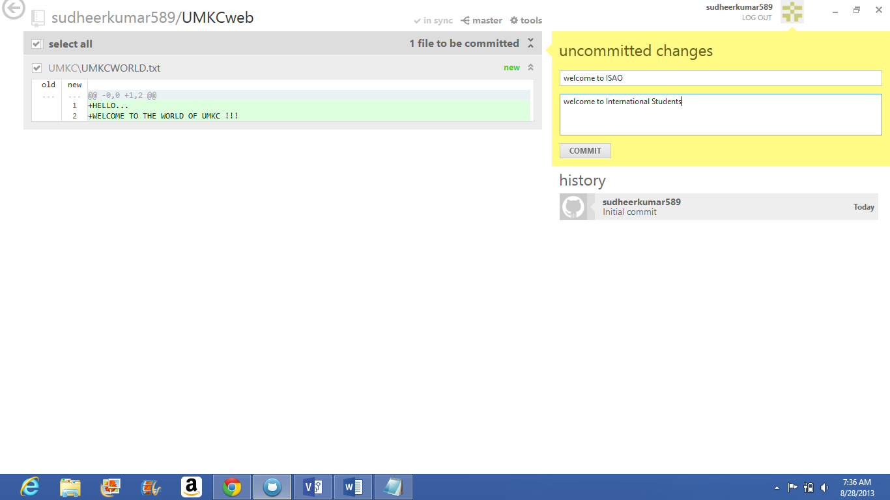

@MAKING COMMITS

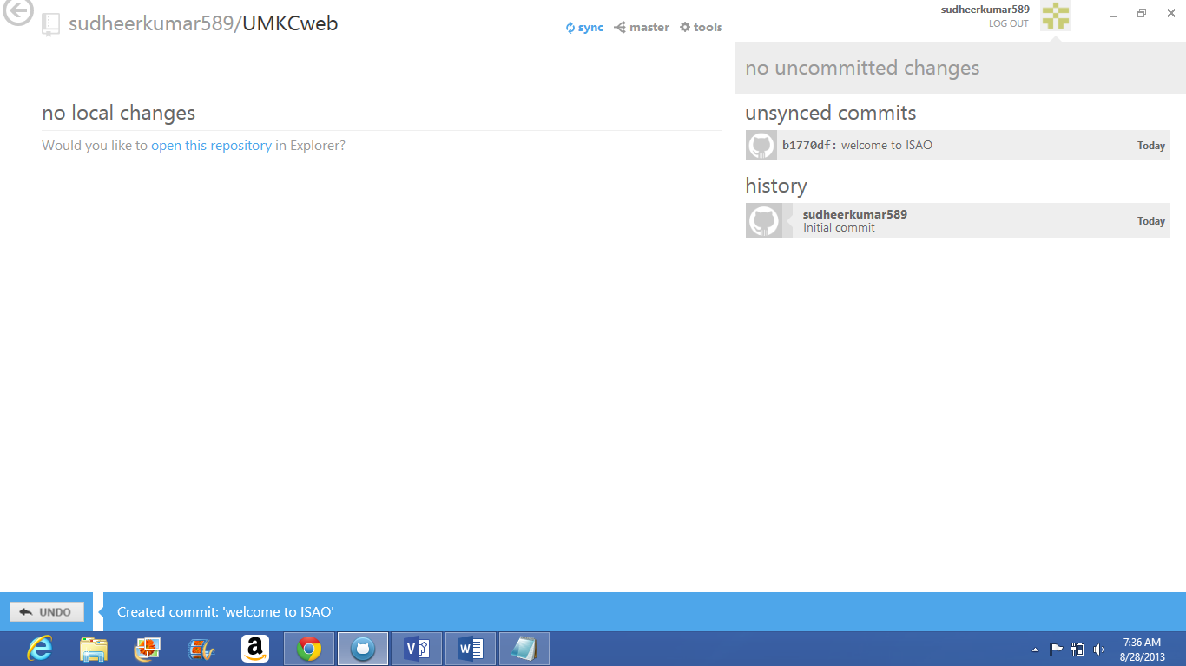

@SYNC

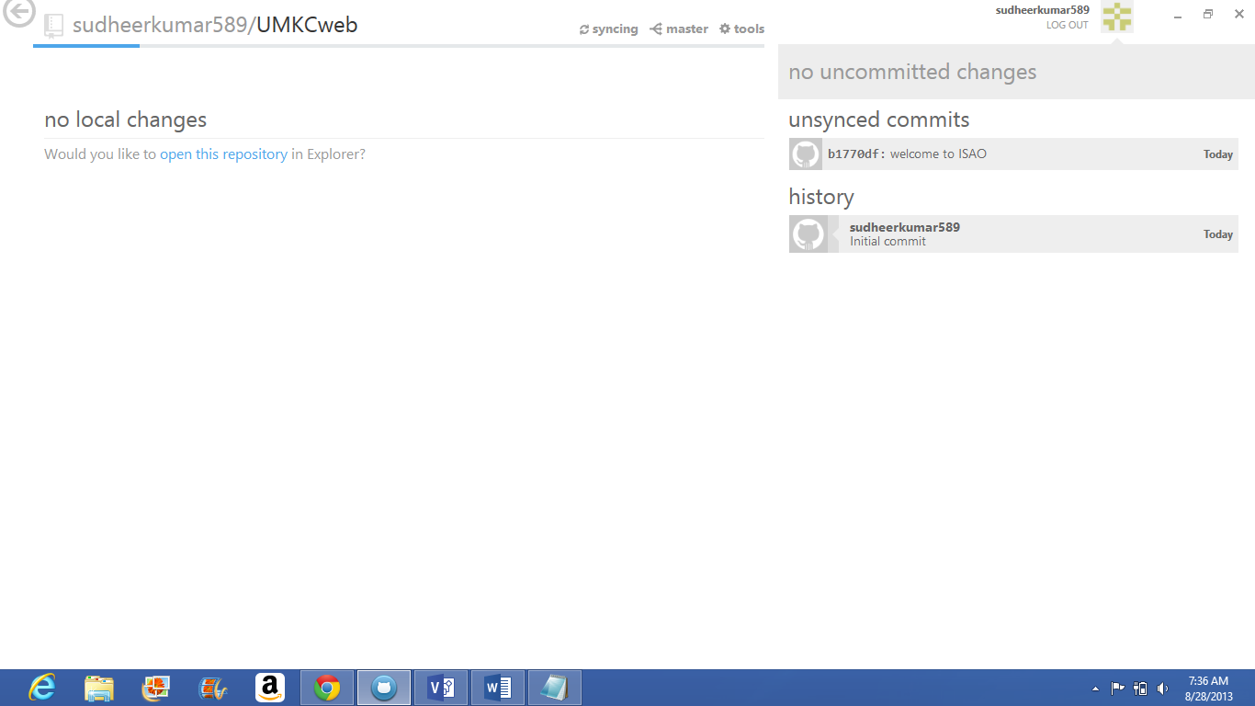

@SYNCING THE COMMITED CHANGES

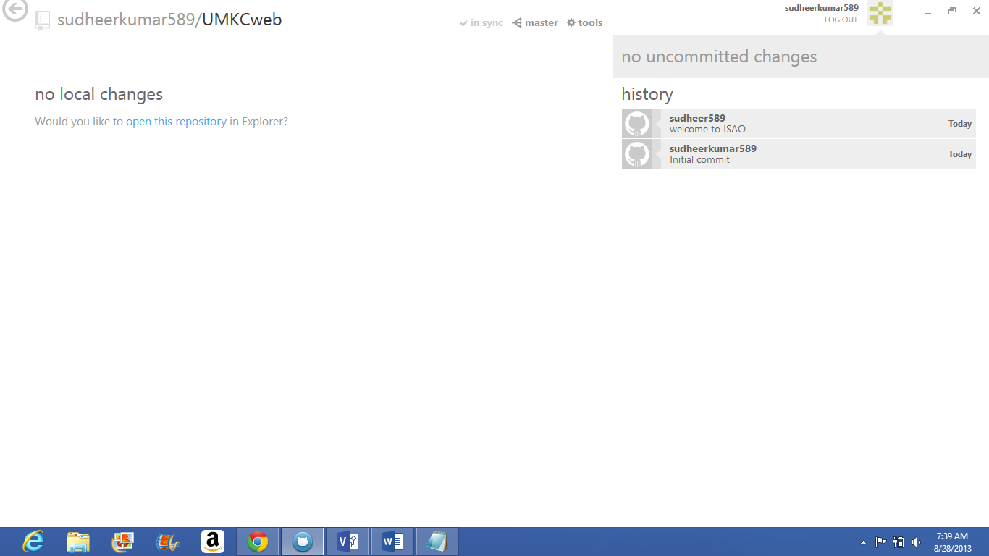

@INSYNC

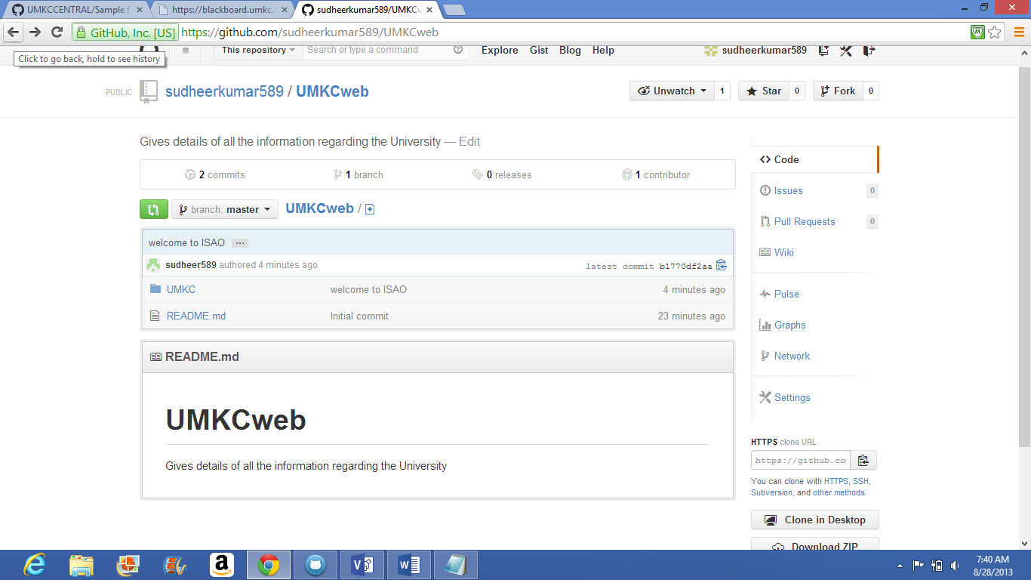

@OPENING THE README FILES

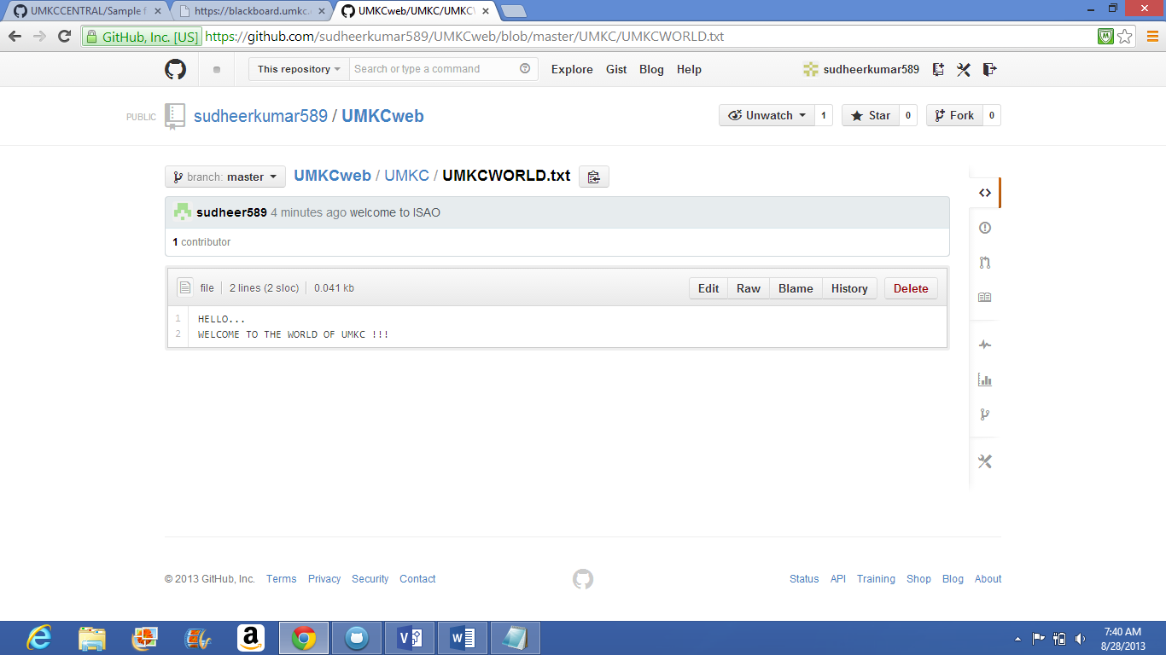

@TEXT FILE

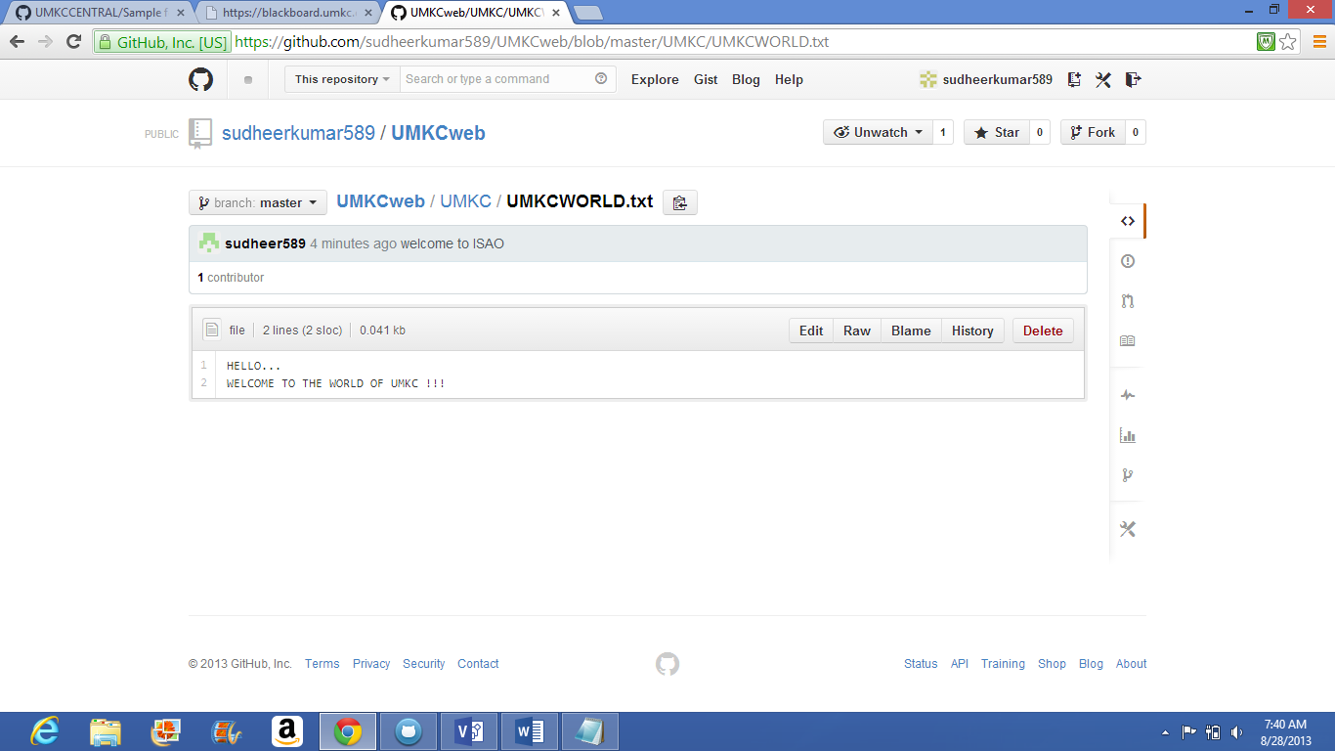

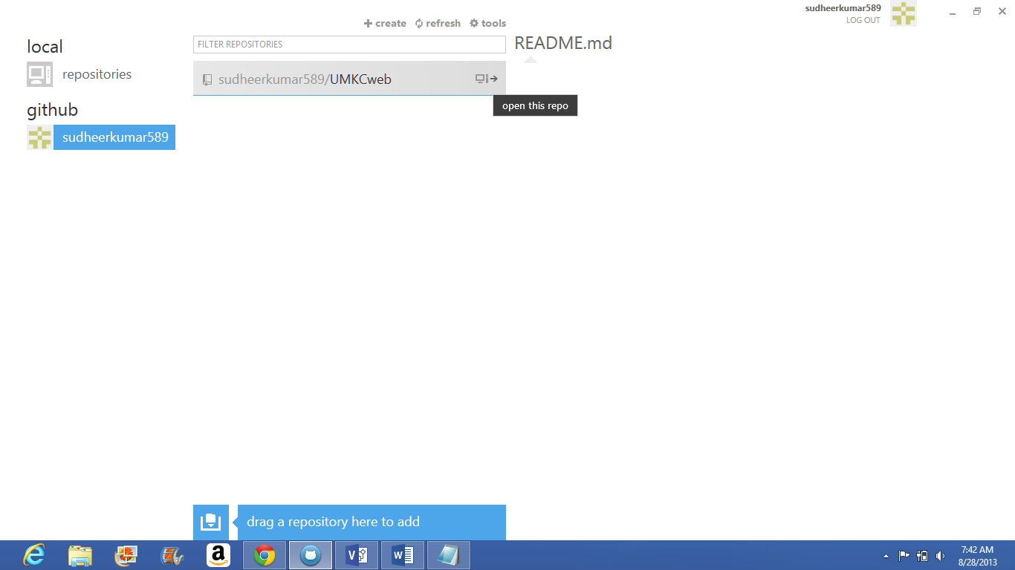

@OPENING THE REPOSITORY

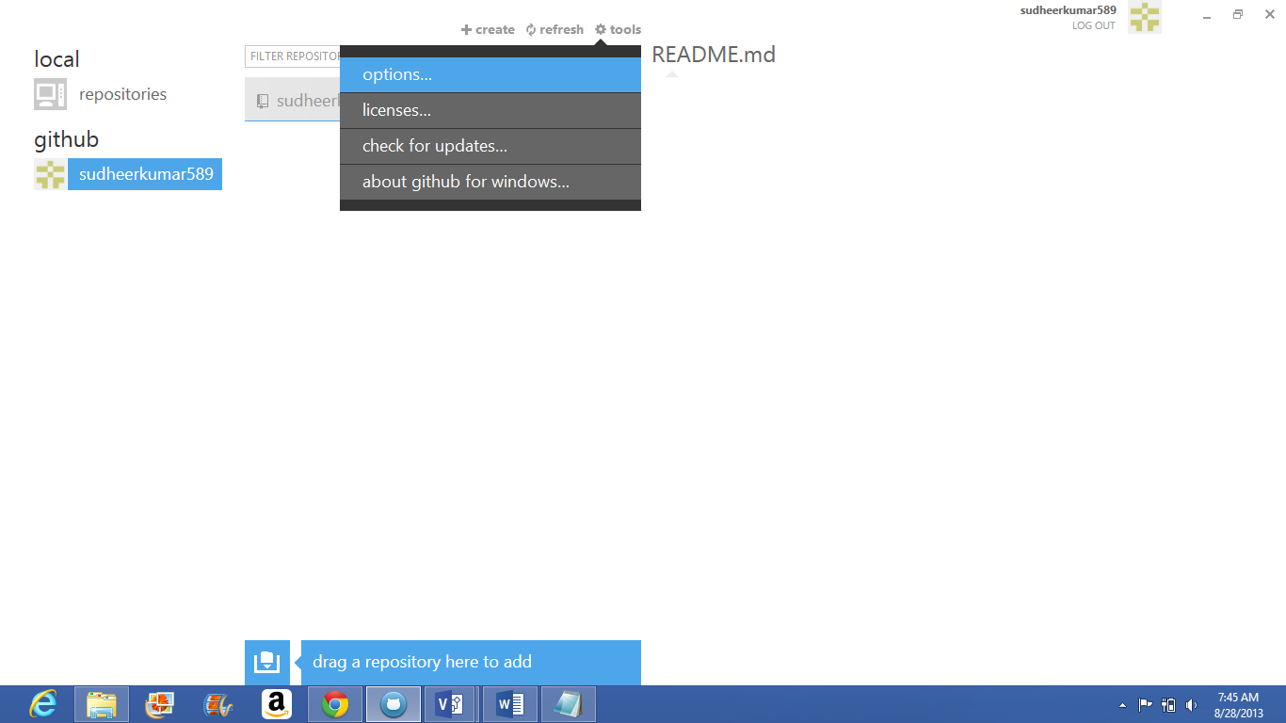

@CHECKING THE OPTIONS AND VERIFYING EMAIL

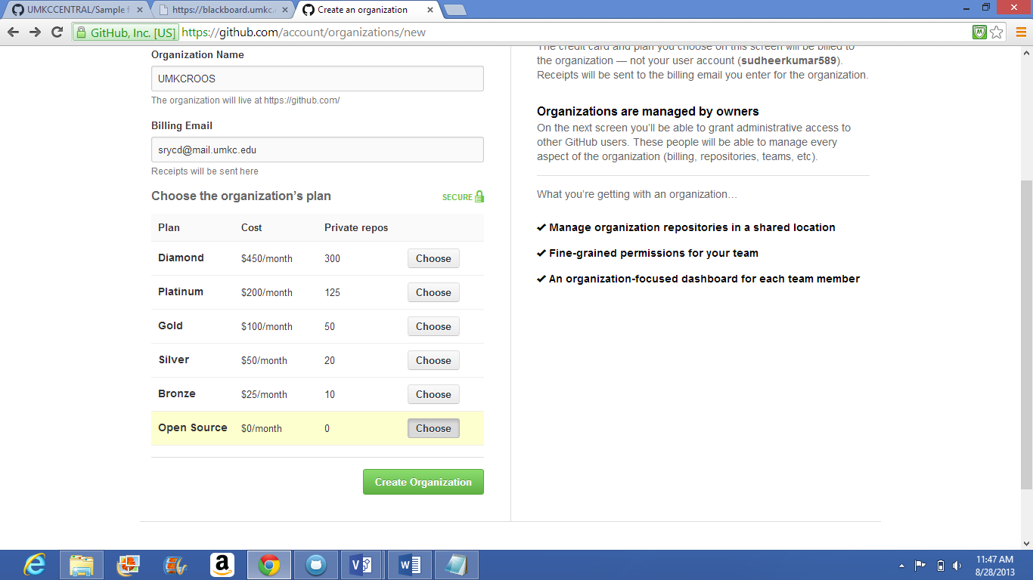

@CREATING ORGANIZATION

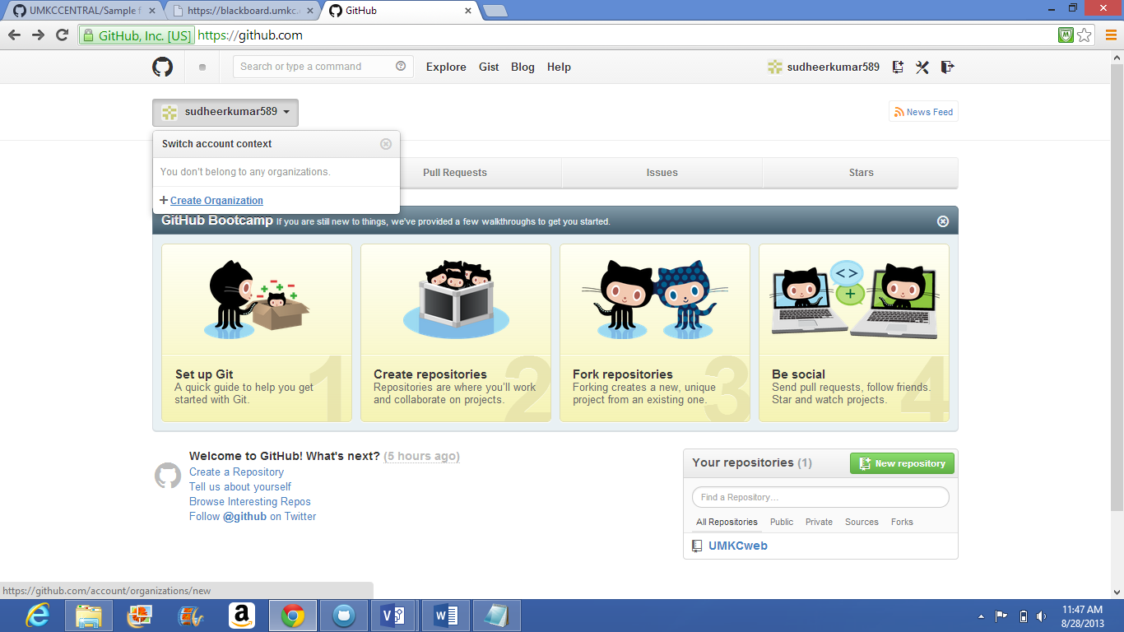

@CREATE NEW ORGANIZATION

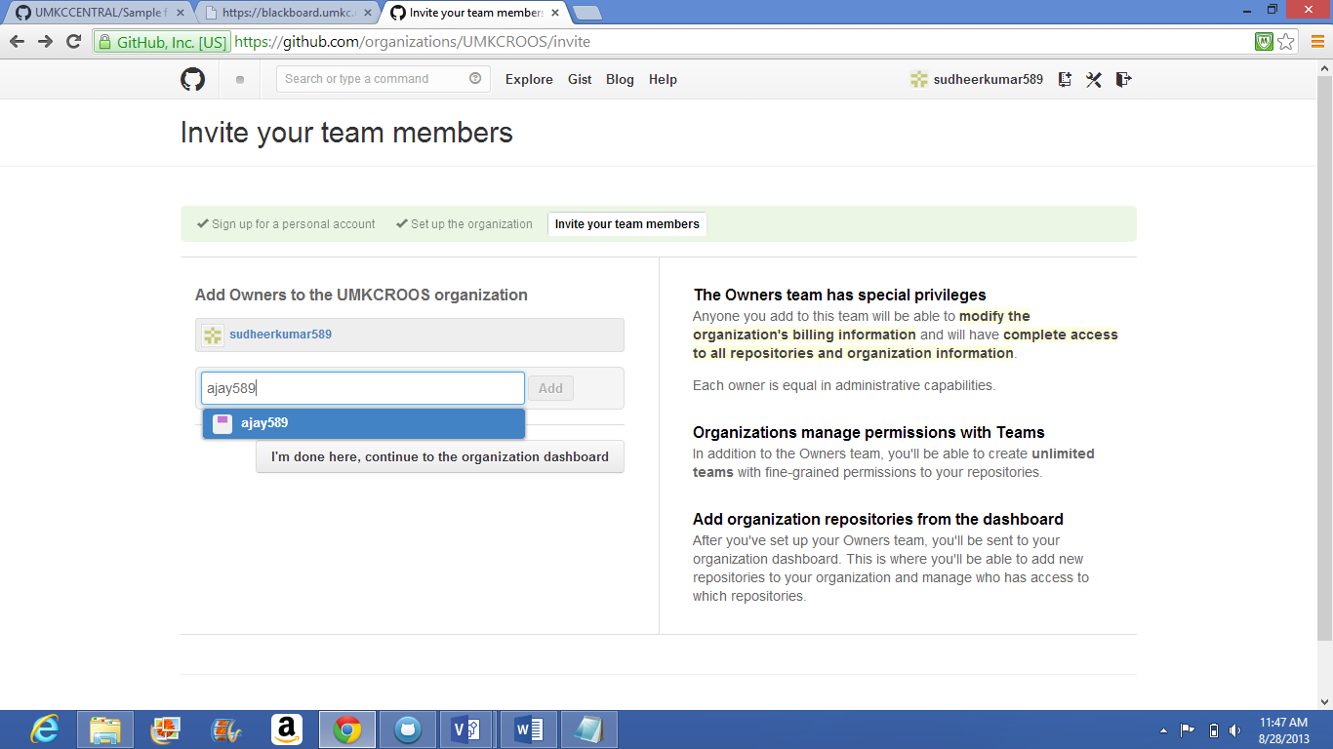

@INVITING TEAM MEMBERS

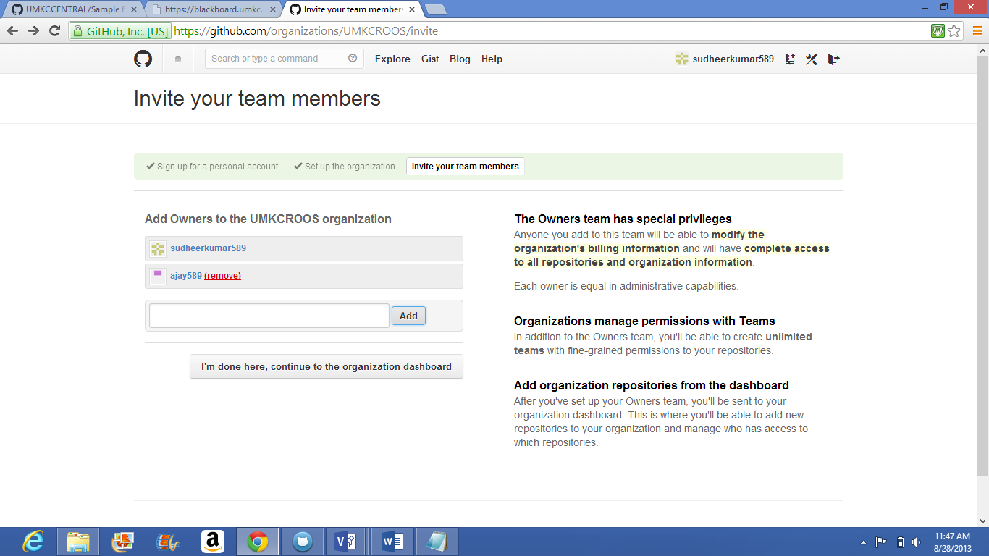

@INVITING TEAM MEMBERS

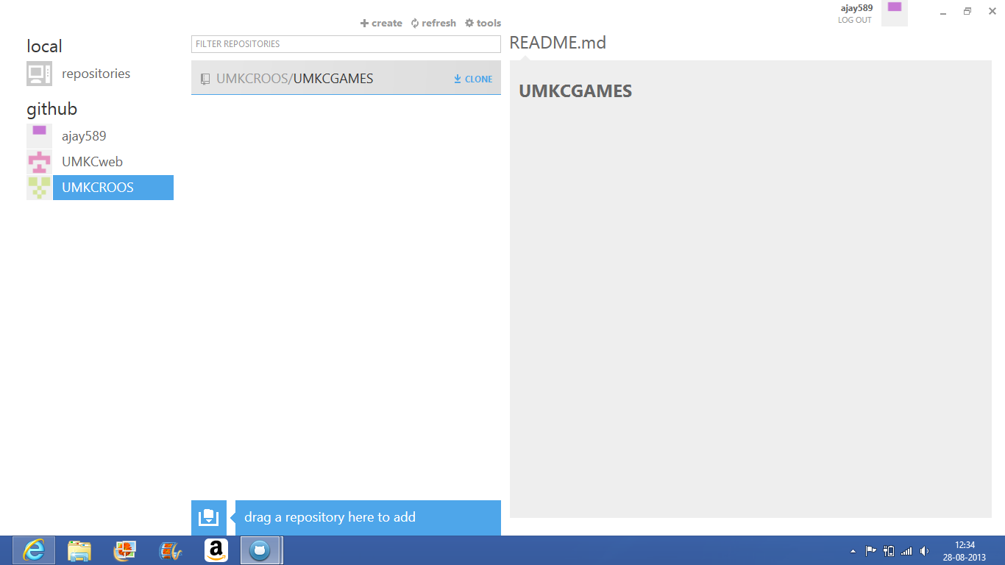

@OPENING GITHUB BY NEW USER



@OPENING REPOSITORIES BY NEW USER

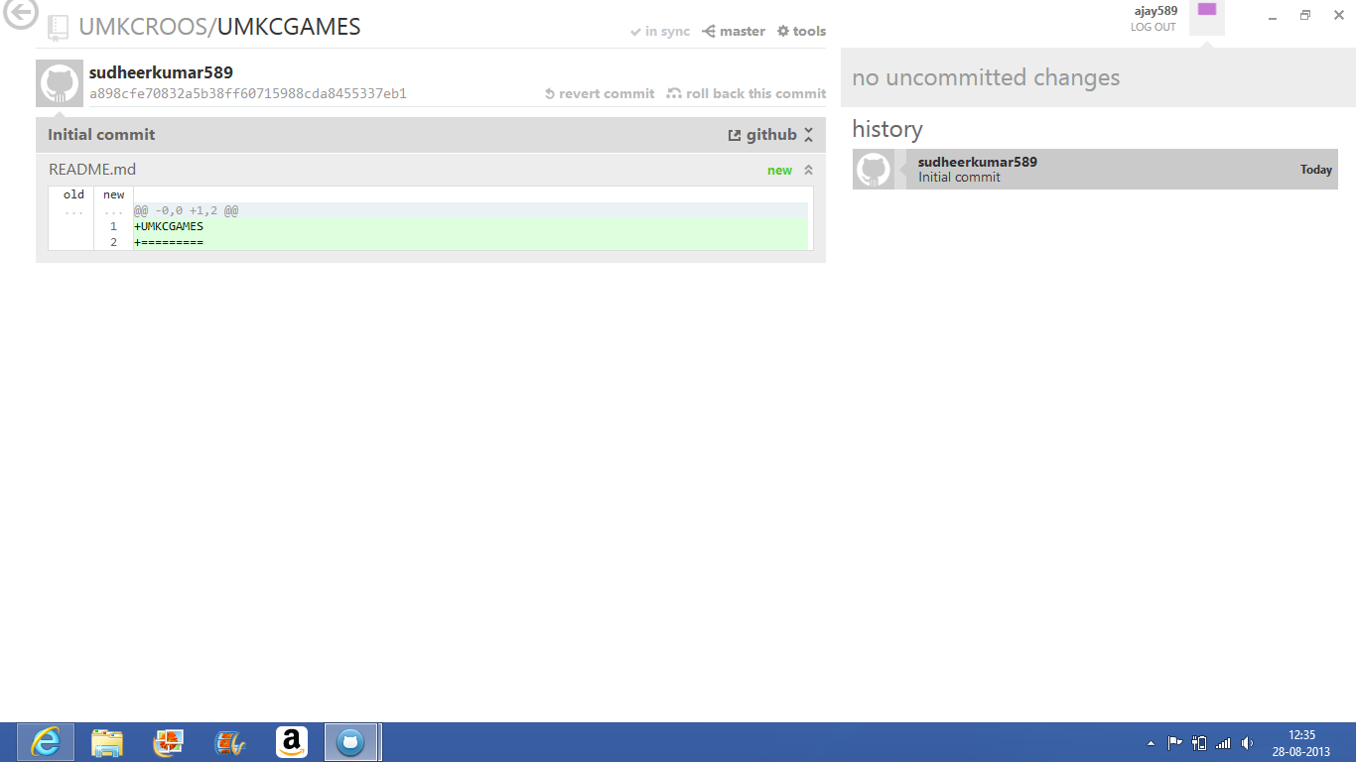

@COMMITING AND SYNCING

THANK YOU